composer install and composer update
# Source: AI Source: Provided by: [Data Path: Persons Table -> ID Column: 1, Name_En Column: Motasem Essam] -> From: [Chatgpt (GPT‑5 Mini)] on [1/26/2026]
Here's a clear breakdown of the difference between composer install and composer update — two of the most important Composer commands in PHP projects.

🛠️ composer install vs composer update
# Source: AI Source: Provided by: [Data Path: Persons Table -> ID Column: 1, Name_En Column: Motasem Essam] -> From: [Chatgpt (GPT‑5 Mini)] on [1/26/2026]
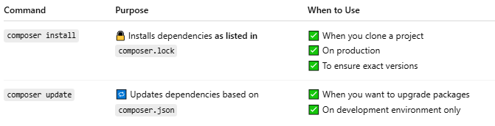
Command | Purpose | When to Use
composer install | 🔒 Installs dependencies as listed in composer.lock | ✅ When you clone a project ✅ On production ✅ To ensure exact versions
composer update | 🔁 Updates dependencies based on composer.json | ✅ When you want to upgrade packages ✅ On development environment only

📦 1. composer install
# Source: AI Source: Provided by: [Data Path: Persons Table -> ID Column: 1, Name_En Column: Motasem Essam] -> From: [Chatgpt (GPT‑5 Mini)] on [1/26/2026]
✅ What it does:
- Reads composer.lock (not composer.json)
- Installs exact versions of dependencies
- Creates vendor/ folder
🧠 Use When:
- Setting up an existing project (git clone)
- Deploying to production
💬 Example:
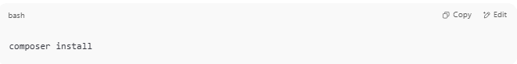
composer install

🔄 2. composer update
# Source: AI Source: Provided by: [Data Path: Persons Table -> ID Column: 1, Name_En Column: Motasem Essam] -> From: [Chatgpt (GPT‑5 Mini)] on [1/26/2026]
✅ What it does:
- Reads composer.json
- Updates to the latest versions allowed by version rules
- Regenerates composer.lock with new versions
🧠 Use When:
- You want to upgrade packages (e.g., to newer versions)
- You added or changed something in composer.json
💬 Example:
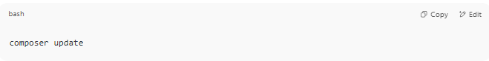
composer update

🧾 Summary Table
# Source: AI Source: Provided by: [Data Path: Persons Table -> ID Column: 1, Name_En Column: Motasem Essam] -> From: [Chatgpt (GPT‑5 Mini)] on [1/26/2026]
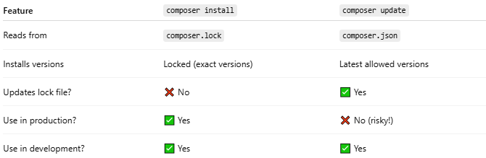
Feature | composer install | composer update
Reads from | composer.lock | composer.json
Installs versions | Locked (exact versions) | Latest allowed versions
Updates lock file? | ❌ No | ✅ Yes
Use in production? | ✅ Yes | ❌ No (risky!)
Use in development? | ✅ Yes | ✅ Yes

🛡️ Tip for Teams
# Source: AI Source: Provided by: [Data Path: Persons Table -> ID Column: 1, Name_En Column: Motasem Essam] -> From: [Chatgpt (GPT‑5 Mini)] on [1/26/2026]
- You commit both composer.json and composer.lock to Git
- This way, your whole team uses the same exact versions
- Run composer install to avoid surprises

